Unloading Using Special sampling

* Steps to do Unloading using Special Sampling.

Use case 1:Unloading with special sampling

* First step to do unloading of vehicle

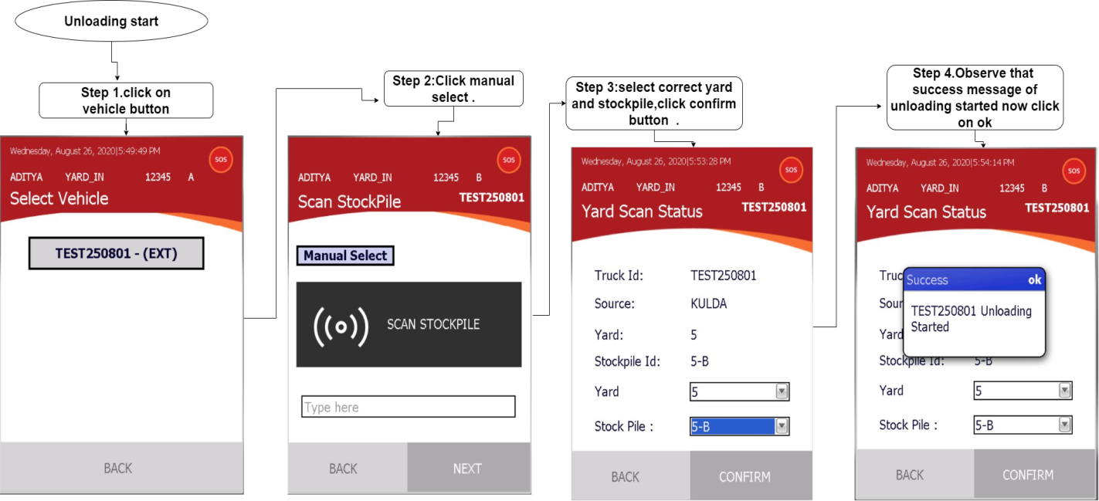

* Second step to do unloading end with vehicle inspection

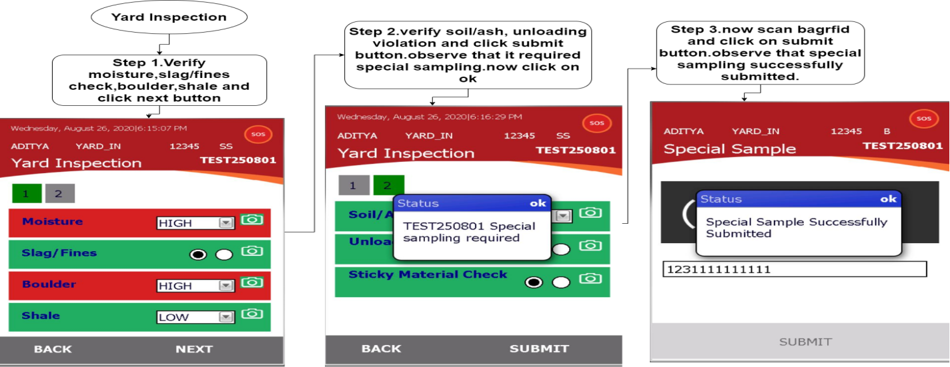

Use case 2:Unloading without special sampling

* First step to do unloading of vehicle



* Second step to do unloading end with vehicle inspection.

